**Al Imam Mohammad Ibn Saud Islamic University**

**College of Computer and Information Sciences**

**Information Systems Department**

**Project management**

Alzheimer Smart Watch

Group no. 3

**Part 1: In order to create a Work Breakdown Structure for your proposed project, you need to:**

1. **Develop a project charter:**

|  |
| --- |
| **Project Title:** Alzheimer Smart Watch.  **Data of Authorization:** October 2  **Project Start Date:** October 2 **Projected Finnish Date:** April 12 |
| **Key scheduled Milestones:**  Complete introduction by 2 of October 2017  Complete estimating cost, time and scope by 20 October 2017  Complete Analysis by 7 December 2017  Complete The final project by 12 April 2018 |
| **Budget Information:**  50,000 for software, hardware and resources. |
| **Project Manager:** Shehana Aljaloud, [ssgelaud@sm.imamu.edu.sa](mailto:ssgelaud@sm.imamu.edu.sa) |
| **Project Objectives:**   1. Designing a system that helps the caregivers to track their patient and notify them when a patient goes out of range. 2. Designing a system that helps the caregivers to send a message when patients get lost. 3. Designing a system that helps Alzheimer’s patients to remember taking their medications. |
| **Risks:**   * + Information leakage.   + Lack of time |
| **Main Project Success Criteria:**  The software must meet all written specifications as (good design, easy to use by user) ,be tested well, and be completed on time .Also ensure the achievement of Privacy |
| **Approach:**  The first challenge we faced was choosing the methodology that we followed, because each project or case suits a different methodology. We selected the waterfall methodology.  We have a limitation with respect to the budget and time. Furthermore, the waterfall methodology is not costly; consequently, we will choose it.  The strengths of the Waterfall methodology are as follows:   * It identifies the system requirements long before programming begins * It minimizes the changes to the requirements as the project proceeds * It is simple and easy to use * The phases do not overlap in this methodology   The weaknesses are as follows:   * The design must be completely specified before the programming begins * Long-time elapses between the completion of the system proposal in the analysis phase and the delivery of the system * It is very difficult to go back and change something in this methodology |

|  |  |  |
| --- | --- | --- |
| **Roles and Responsibilities** | | |
| **Name** | **Role** | **Contact information** |
| Dr. Lujain Aldahash | Supervisor | [laaldahash@imamu.edu.sa](mailto:laaldahash@imamu.edu.sa) |
| Ahad Alosaimi | Team Member |  |
| Halah Alhassan | Team Member |  |
| Ruba Alrajeh | Team Member |  |
| Shehana Aljaloud | Project manager | [ssgelaud@sm.imamu.edu.sa](mailto:ssgelaud@sm.imamu.edu.sa) |
| Sign-off :( Signatures of all the above stakeholders) Shehana Aljaloud: Shehana  Ahad Alosaimi: Ahad  Halah Alhassan: Halah  Ruba Alrajeh: Ruba | | |

1. **Collect requirements:**

**2.1Gathering Information:**

For this project, an electronic questionnaire, designed by Google Drive in Arabic language, was published via Twitter from December 5, 2017 to December 7, 2017. A total of 177 people responded to this questionnaire.

**2.1.1 The structure is:**

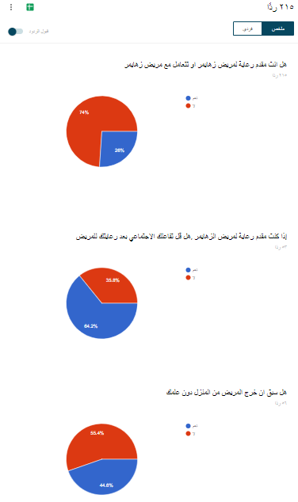

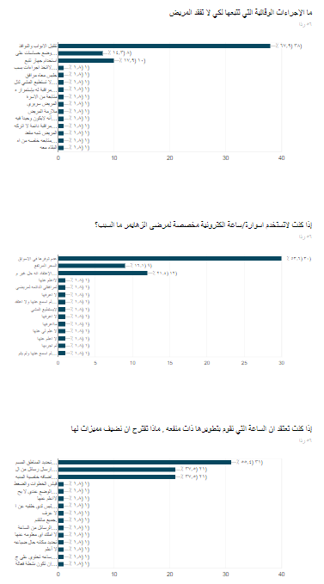

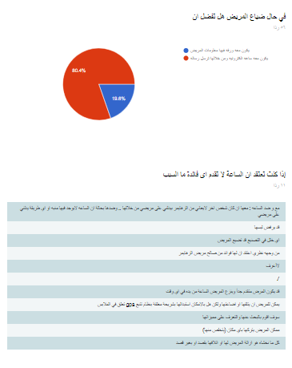

* + 1. **The Results**

**First,** 215 people answered the questionnaire, 26% of whom were caregivers or had Alzheimer patients at home.

* 64.2% of caregivers were found to reduce their social interaction thus proving Squires’ AARP article that was mentioned in Chapter 1: “Caregivers often work by themselves, and more than half (53%) say they have less time for friends and family. All too often, they do not call doctors when they are sick, and they have little or no time to exercise or eat well. Studies show that up to 70% of caregivers have clinically significant symptoms of depression” [3].
* More than 44% of the patients were found to have gone out without the knowledge of their caregivers.
* 65.7% of the caregivers were found to have the tendency to close doors to protect their patients, and 14.8% tend to use cameras to keep an eye on their patients; however, we do not prefer the violation of patient privacy.

* For many reasons, caregivers do not use warble technologies that target Alzheimer's patients: 52.6% don’t use it because it is not available in the market, 15.8 % because of its high price and 21.1% don’t think it to be useful.

* When we asked the participants to suggest features to be added in the "Alzheimer Smart Watch", the answers were as follows: 54.4% suggested the selection of range, 38.6% suggested the option to send a message and 36.8% wanted to add an alarm. Fortunately, all these features are already in our smart watch. Some people also suggested the exchange of messages between the application and smart watch; this is great idea, but our scope limited as Alzheimer patients are either illiterate or they have a tendency to forget how to read. Another common problem of Alzheimer disease is visionproblem [22]. The send message feature of the "Alzheimer Smart Watch" is target the person who will fine the patient.

* In cases where the patient gets lost, 80.7% caregivers prefer that patient wear a smart watch, not to have note that content their information.

## Requirements:

|  |  |
| --- | --- |
| (Alzheimer patient) requirement | |
| System requirement | **User requirement** |
| 1. The system shall be able to show massages | 1. Alzheimer patient shall be able to receive massages. |
| 1. The system shall be able to show an alarm | 1. Alzheimer patient shall be able to receive alarms. |
| 1. The system shall be able to use GPS | 1. Alzheimer patient shall be able to be tracked. |
| (caregivers) requirement | |
| System requirement | **User requirement** |
| 1. The system shall be allow to create account by   1.1 email  1.2 password | 1. The caregivers shall be able to create account |
| 1. The system allow be able to log in by   2.1 email  2.2 password  2.3 The system should be verifying a username and password | 1. The caregivers shall be able to log in |
| 1. The system shall be allow caregiver to view the GUI contents   3.1 Alarm  3.2Massage  3.3Location | 1. The caregivers shall be able to view the GUI |
| 1. The system shall be allow caregiver to add alarm | 1. The caregivers shall be able to add alarm |
| 1. The system shall be allow caregiver to delete alarm | 1. The caregivers shall be able to delete alarm |
| 1. The system shall be allow caregiver to modify alarm | 1. The caregivers shall be able to modify alarm |
| 1. The system shall be allow caregiver to send massages | 1. The caregivers shall be able to send massages |
| 1. The system shall be allow to notification when watch out of the ring | 1. The caregivers shall be able to choose range |
| 1. The system shall be allow to use GIS | 1. The caregivers shall be able to use GIS |

1. **Define scope:**

By creating the “Alzheimer Smart Watch”, we hope to improve the quality of life of those who are suffering from Alzheimer’s in its early and middle stages, as well as the lives of their caregivers. Unfortunately, we have not targeted those with late-stage Alzheimer’s because in this stage, patients lose their physical abilities, such as walking, sitting, and even swallowing [5]. On the other hand, the caregivers should have a basic knowledge of technology, such as the knowledge of using the application which we have designed.

The “Alzheimer Smart Watch” is divided into two parts: the application and the smart watch. The application can be used by the caregivers on an Android and IOS. The application will use GIS technology along with a GPS. In case of the watch, an IOT technology will be used in terms of the hardware which the Alzheimer’s patient shall wear.

•So far, there is no official statistics about the numbers of Alzheimer's patients in Saudi Arabia. However, in 2014, it was over a million [6].

•There are nearly 44 million people worldwide who suffer from Alzheimer’s or related dementia [12]. (Alzheimer Disease International)

•Only 1-in-4 people with Alzheimer’s disease have been diagnosed [7]. (Alzheimer Disease International)

•2-in-3 people with Alzheimer’s are women [8]. (Alzheimer Association)

However, in our project "Alzheimer Smart Watch", we will only target the people with Alzheimer’s disease in Saudi Arabia, the team do not target children or people with autism.

1. **Create the WBS:**

A work breakdown structure (WBS) is a key project that is deliverable, which organizes the team's work into manageable sections. The Project Management Body of Knowledge (PMBOK) defines the WBS as a "deliverable-oriented hierarchical decomposition of the work to be executed by the project team." The WBS visually defines the scope into manageable chunks that a project team can comprehend, as each level of the WBS provides further definition and detail. For **only one WBS item**, write the description as in the WBS Dictionary. All WBS dictionary items should be correct, clear and well written.

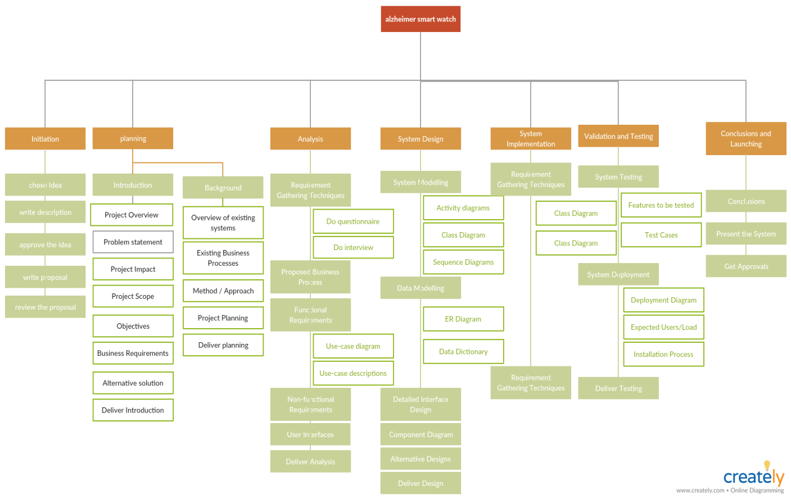

|  |
| --- |
| W  **WBS Dictionary October 15**  Dictionary Entry March 2try March 20 |
| **Project Title:** Alzheimer Smart Watch. |
| **WBS Item Number:** 01 |
| **WBS Item Name:** Initiation |
| **Description:** It is a formal document containing a common description of what is expected to be done within the project, what prerequisites for the project are, and how to produce the expected amount of work. The document is to be created prior to the implementation process to make a foundation for further goal setting and implementation |

The WBS Tabular form:

1. Initiation
   1. chose idea
   2. write description
   3. submit the discretion
   4. approve the idea
   5. write proposal
   6. review the proposal
2. Planning
   1. Introduction
      1. Project Overview
      2. Problem statement
      3. Project Impact
      4. Project Scope
      5. Objectives
      6. Business Requirements
      7. Alternative solution
      8. Chapter Documentation
   2. Background
      1. Overview of existing systems
      2. Existing Business Processes
      3. Method / Approach
      4. Project Planning
   3. Deliver planning
3. Analysis
   1. Requirement Gathering Techniques
      1. Do questionnaire
      2. Do interview
   2. Proposed Business Process
   3. Functional Requirements
      1. Use-case diagram
      2. Use-case descriptions
   4. Non-functional Requirements
   5. User Interfaces
   6. Deliver Analysis
4. System Design
   1. System Modelling
      1. Activity diagrams
      2. Class Diagram
      3. Sequence Diagrams
   2. Data Modelling
      1. ER Diagram
      2. Data Dictionary
   3. Detailed Interface Design
   4. Component Diagram
   5. Alternative Designs
   6. Deliver Design
5. System Implementation
   1. System Specification
      1. Hardware Specifications
      2. Software Specifications
   2. Deliver Implementation
6. Validation and Testing
   1. System Testing
      1. Features to be tested
      2. Test Cases
   2. System Deployment
      1. Deployment Diagram
      2. Expected Users/Load
      3. Installation Process
   3. Deliver Testing
7. Conclusions and Launching
   1. Conclusions
   2. Present the System
   3. Get Approvals

**Part 2: In order to develop the project schedule you need to:**

1. **Define activities:**

**Gantt chart**

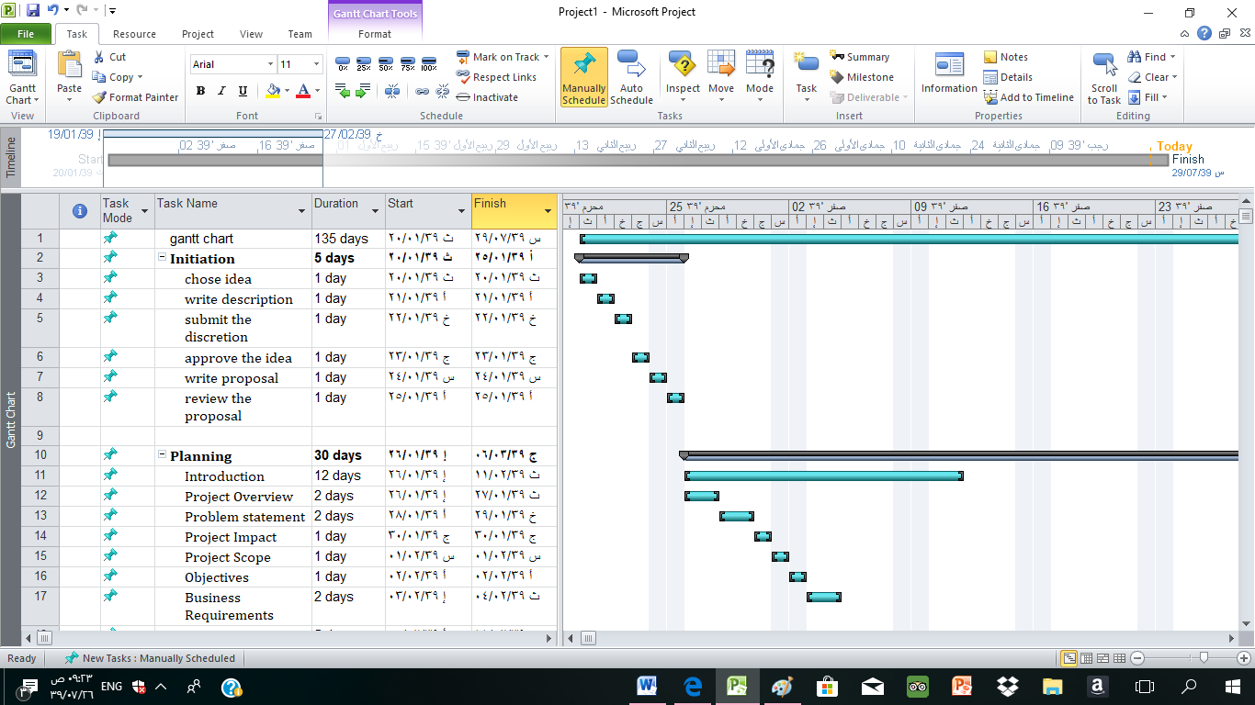

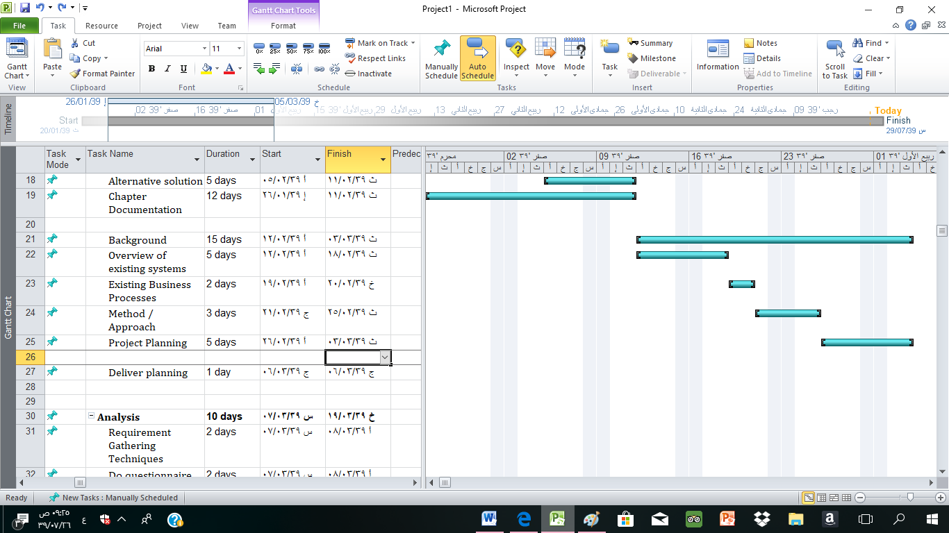

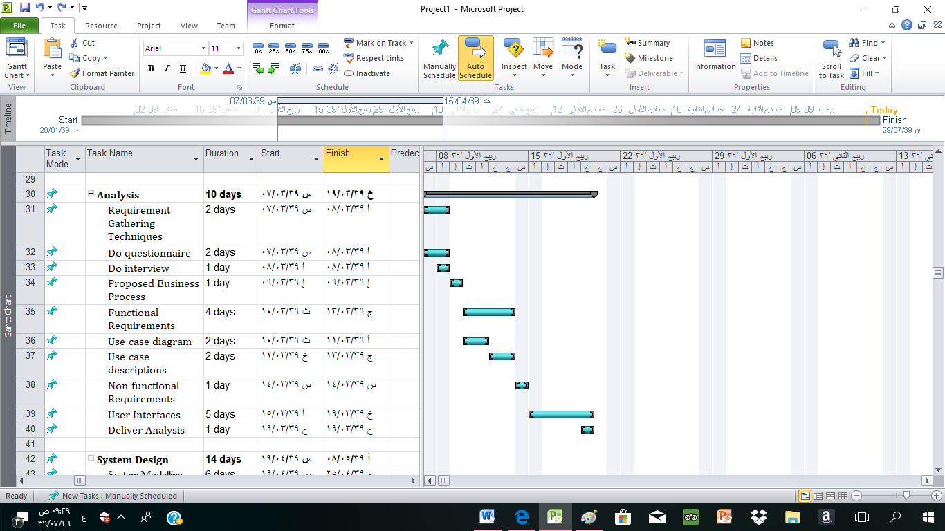

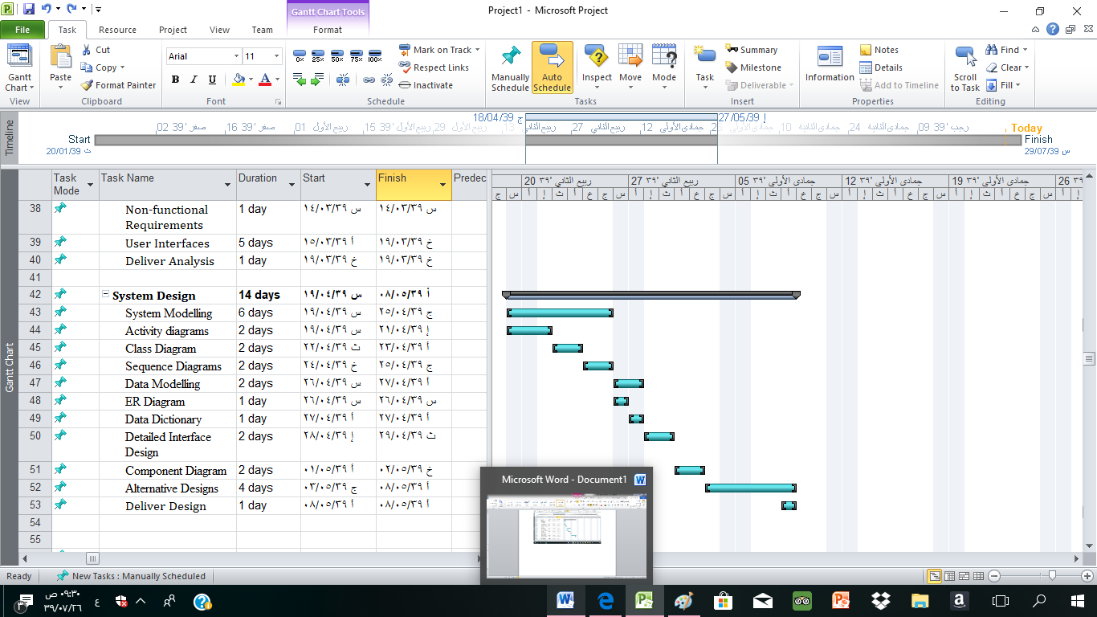

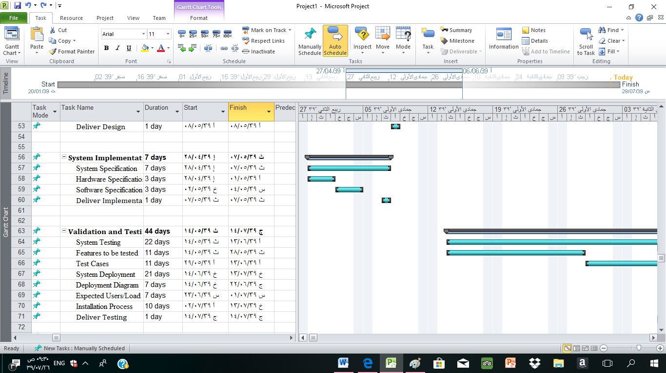

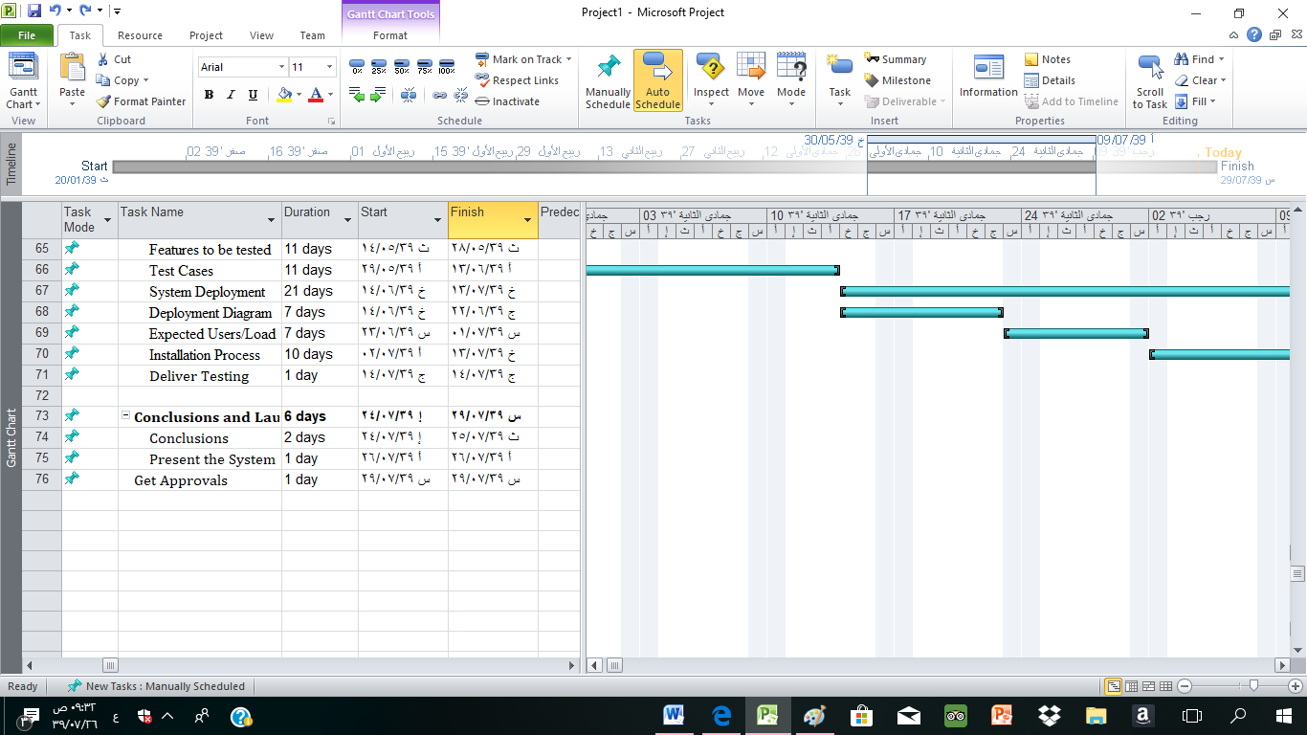

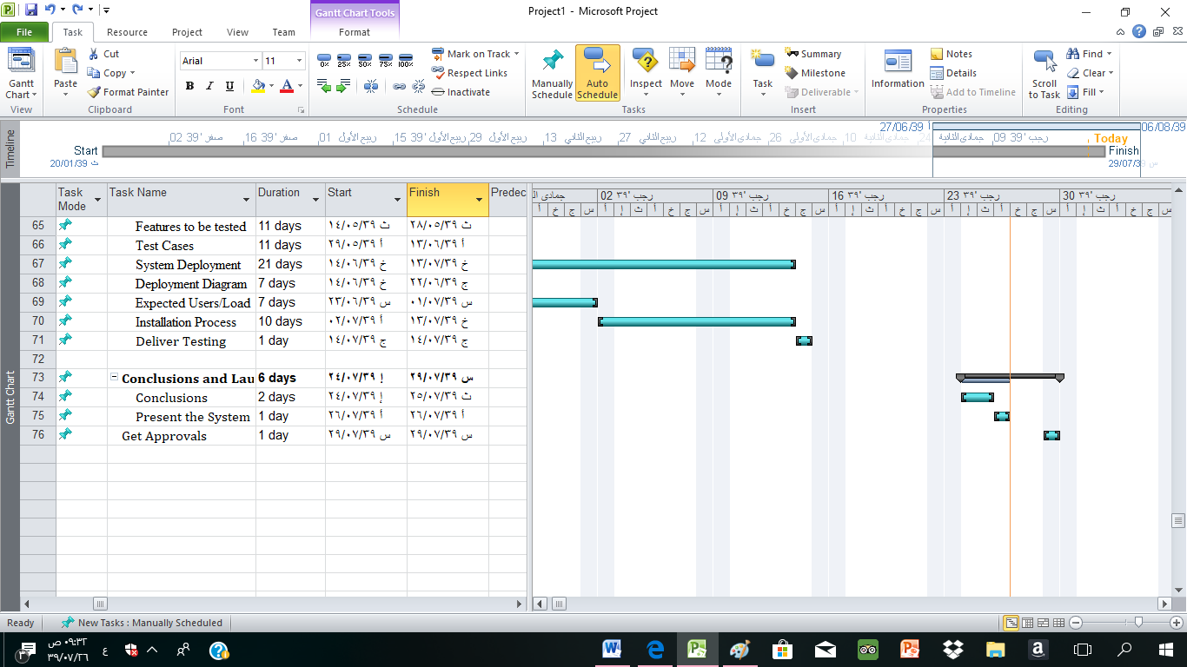

**Create calendar:**

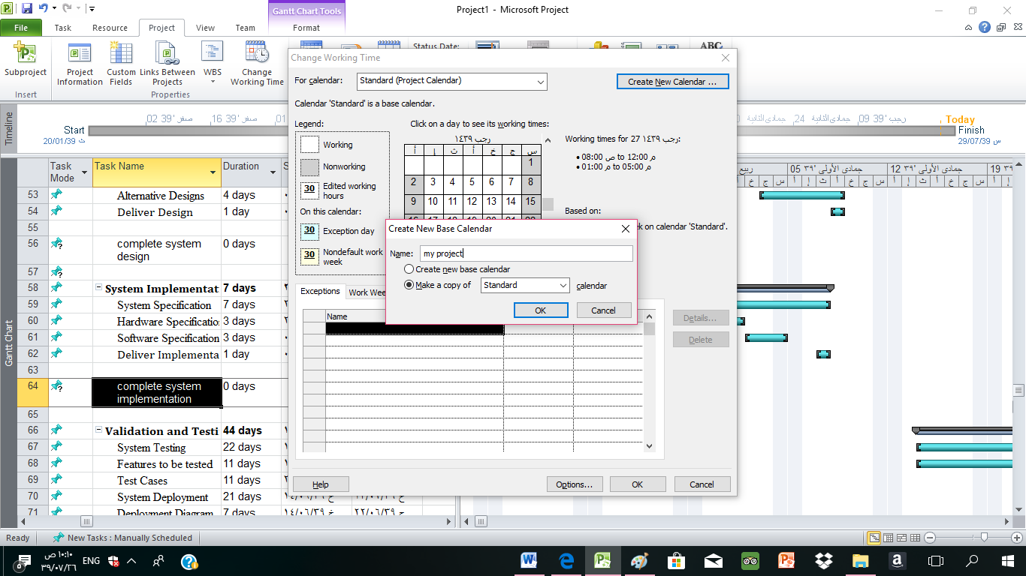

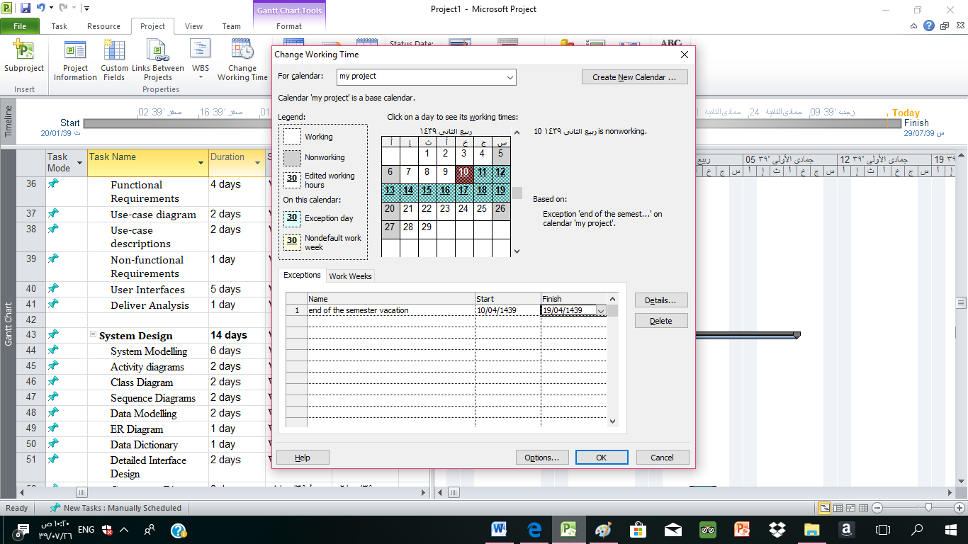

* + Define the **milestones**

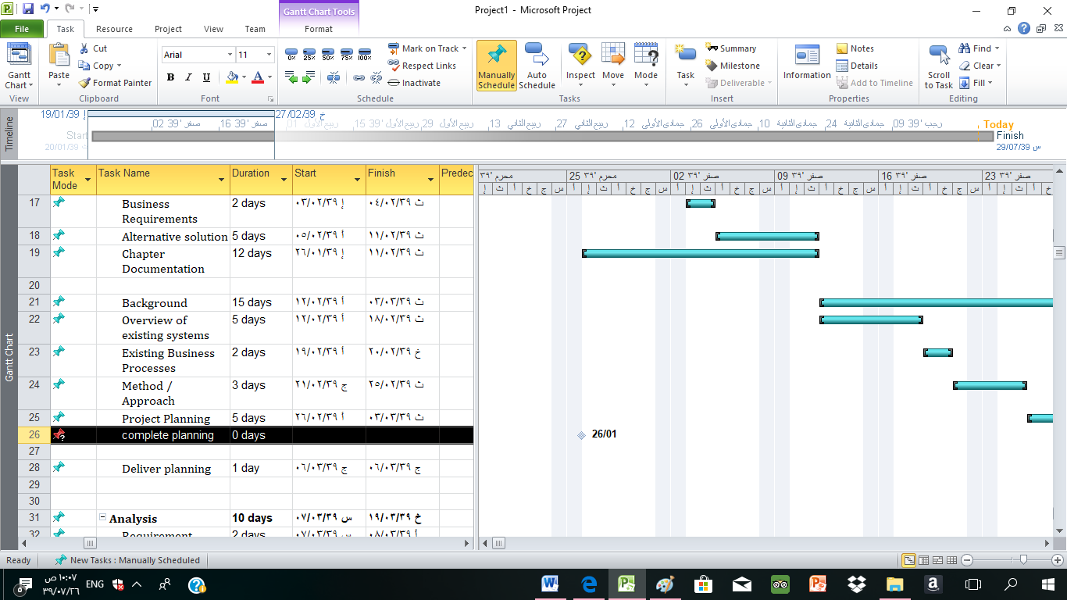

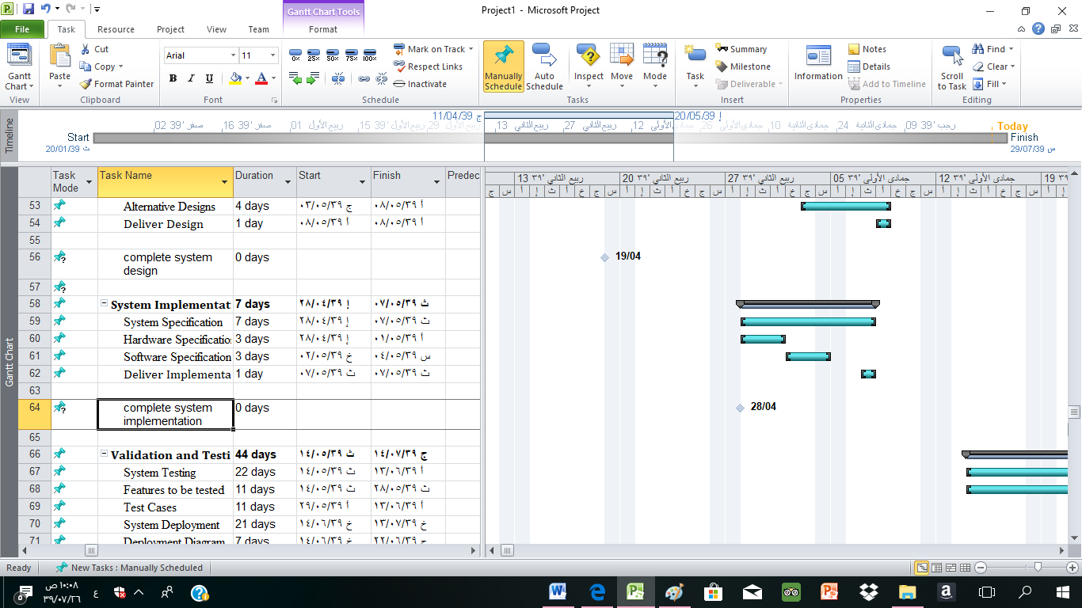

**estimate activity duration**

|  |  |  |  |  |  |
| --- | --- | --- | --- | --- | --- |
| Activity | predecessor | Duration | | | Expected duration (mean duration) |
| Optimistic | Most likely | Pessimistic |  |
| A-Initiation | - | 2 | 4 | 5 | 4 |
| B-Planning | A | 15 | 20 | 30 | 21 |
| C-Analysis | A | 5 | 8 | 10 | 8 |
| D-System design | C | 10 | 12 | 14 | 12 |
| E-System implementation | C | 5 | 6 | 7 | 6 |
| F-Validation& Testing | E | 20 | 30 | 44 | 31 |
| G-Conclusion& Lunching | F | 2 | 4 | 6 | 4 |

The project network:

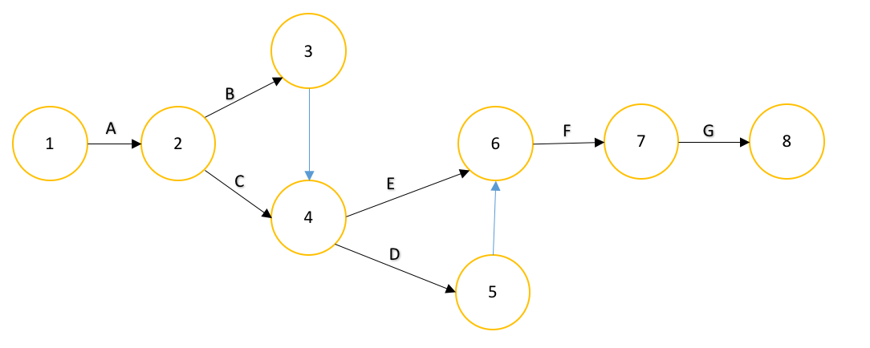

Show **NW diagram** view

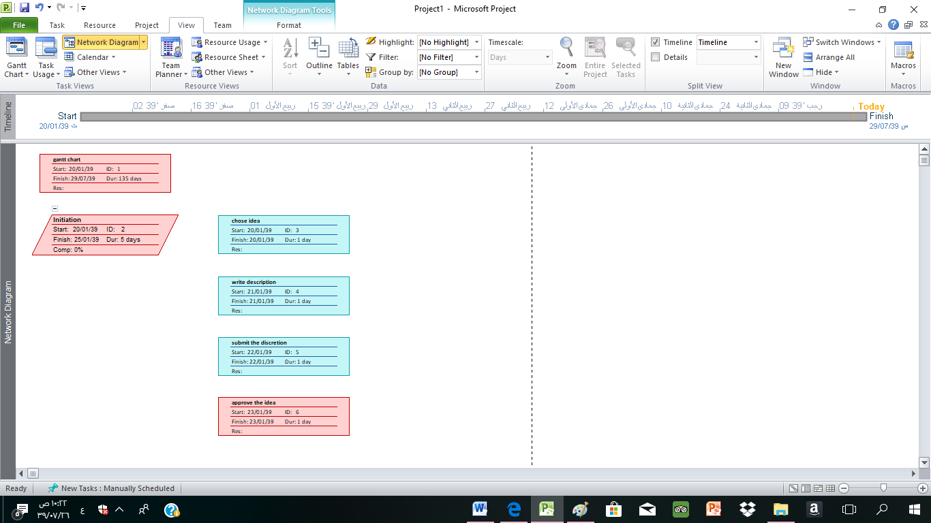

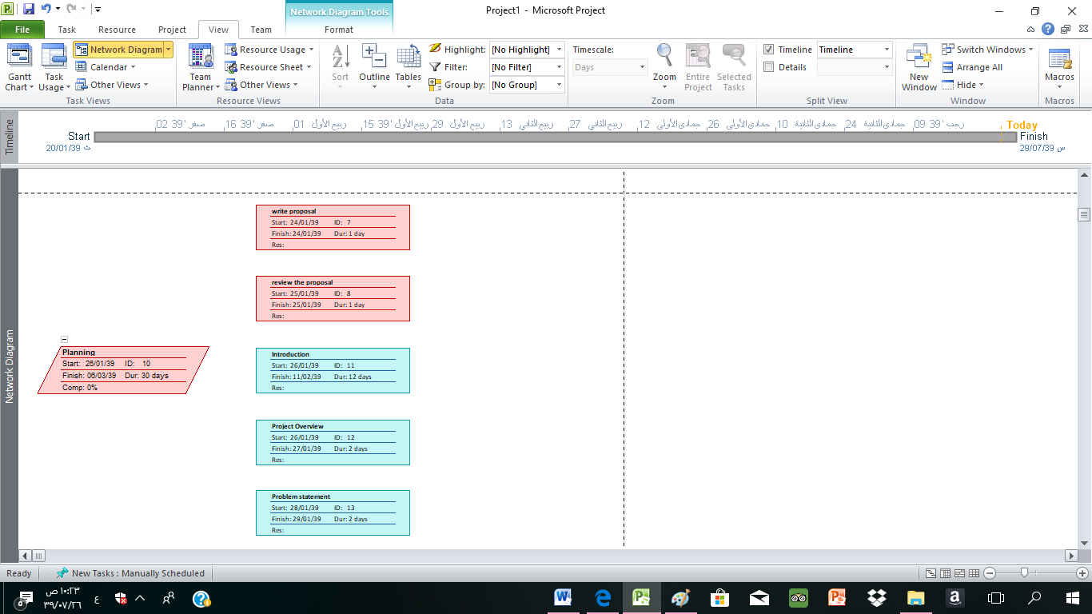

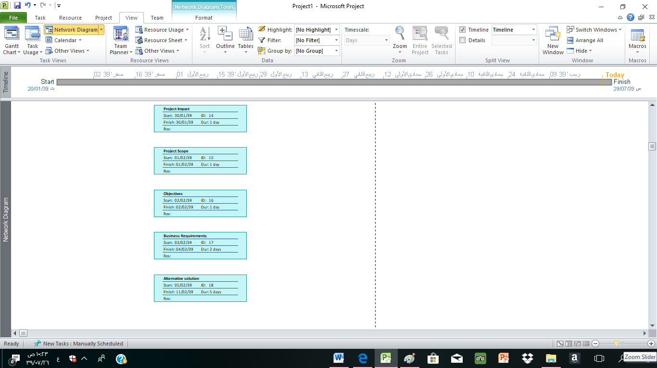

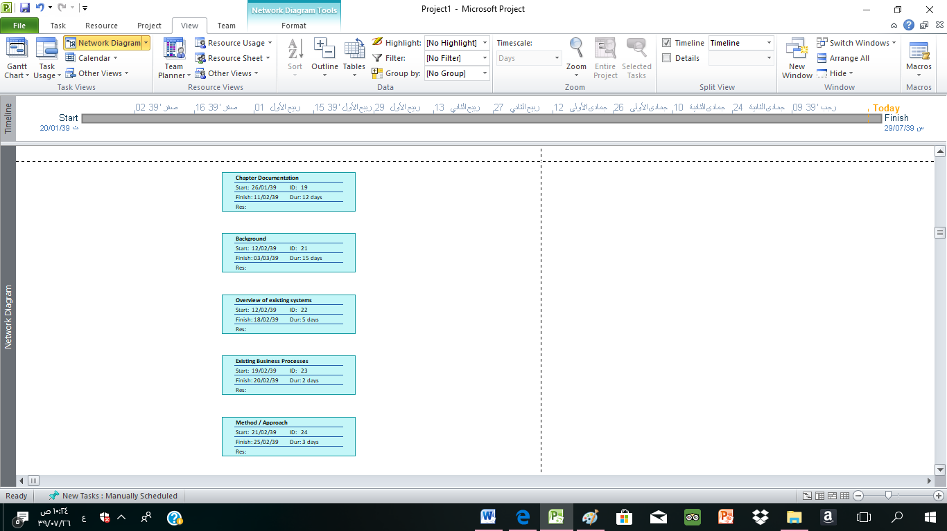

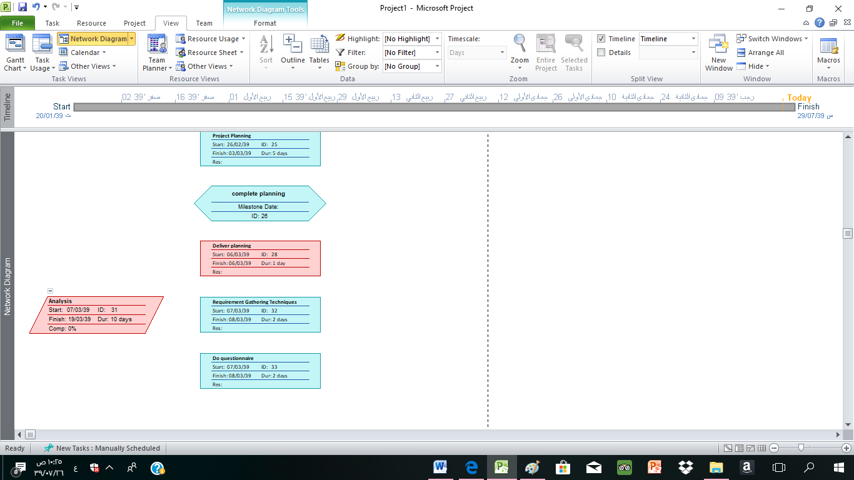

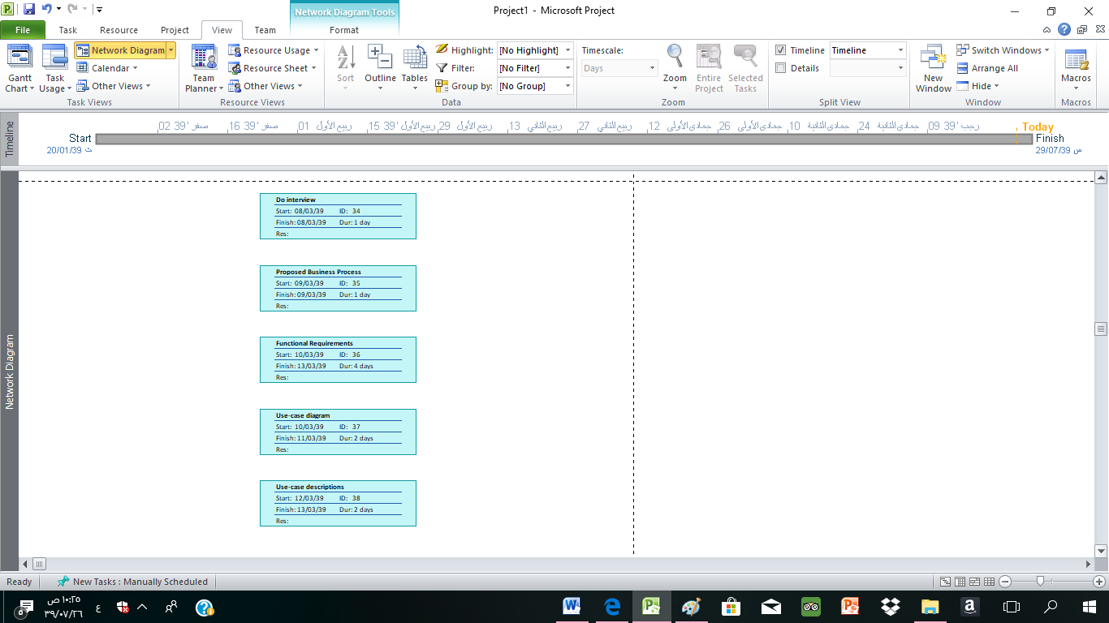

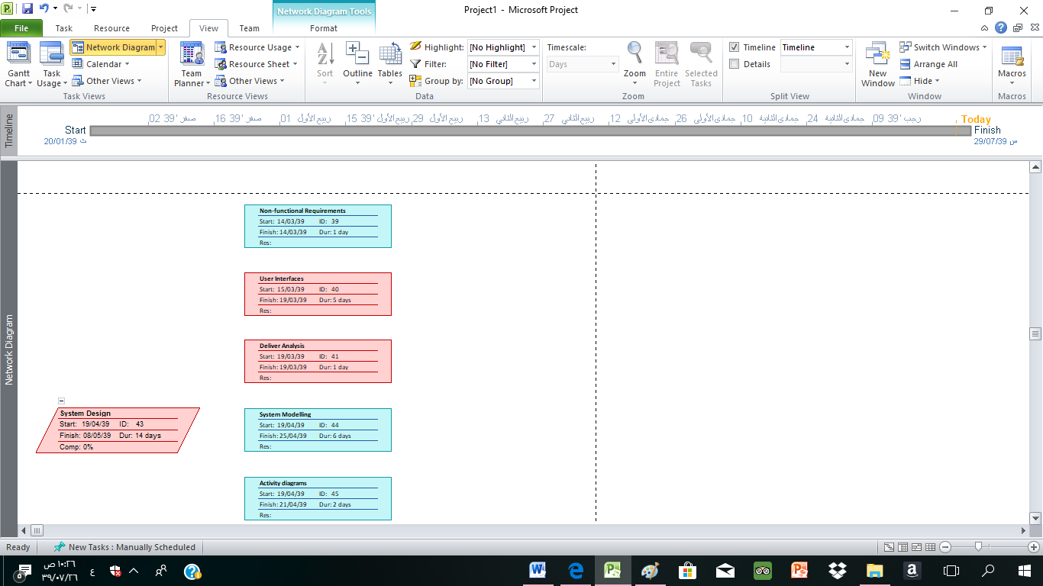

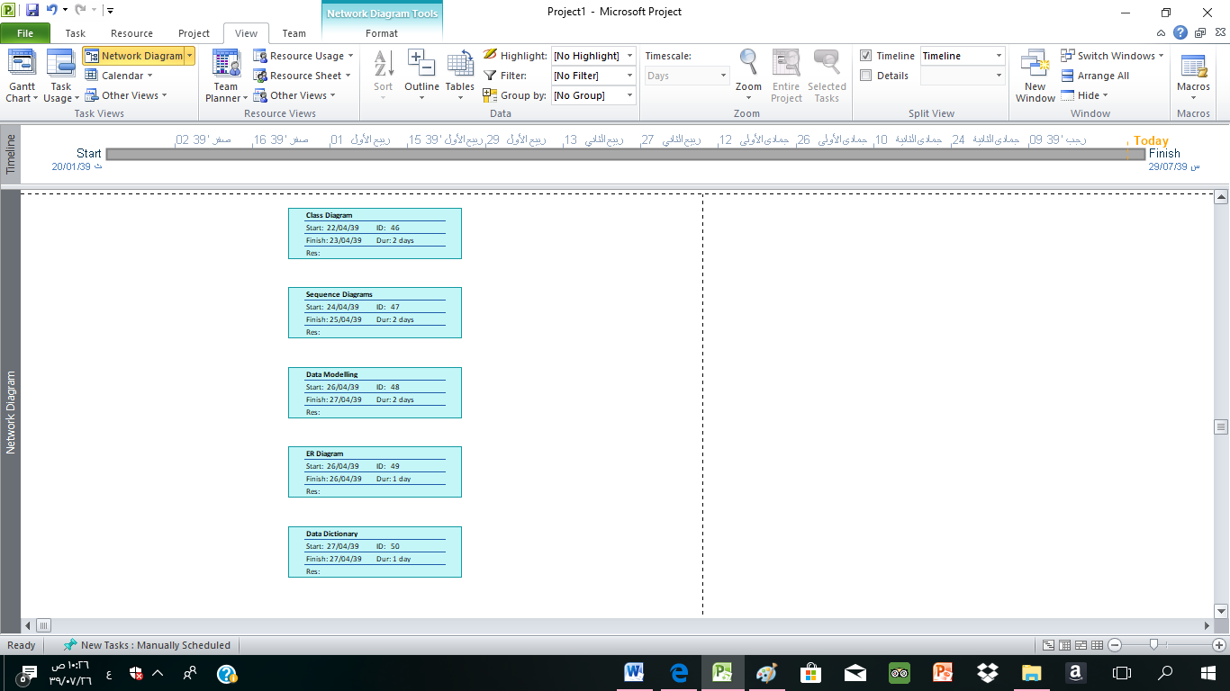

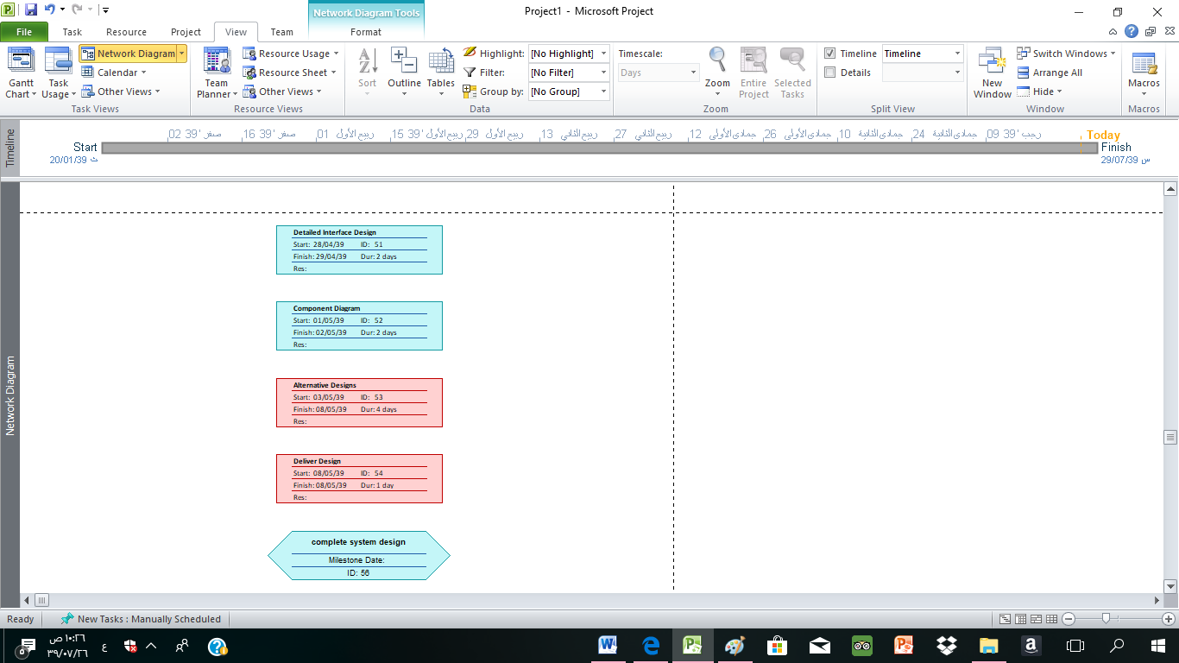

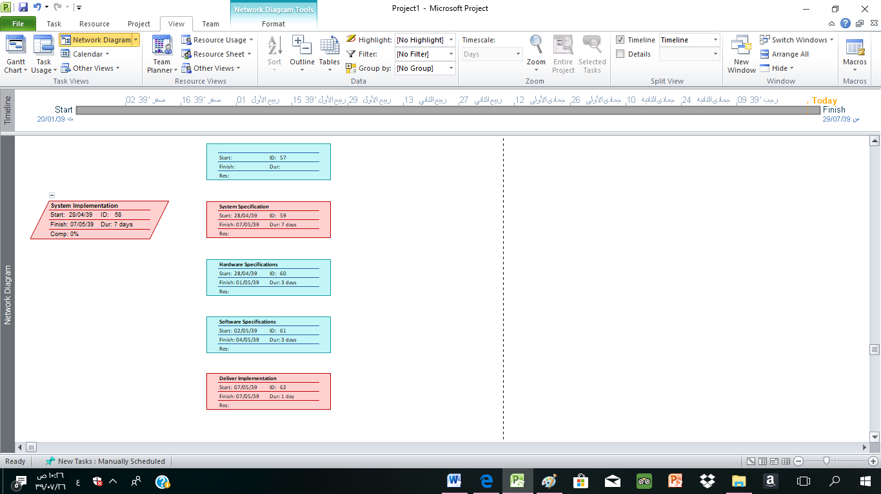

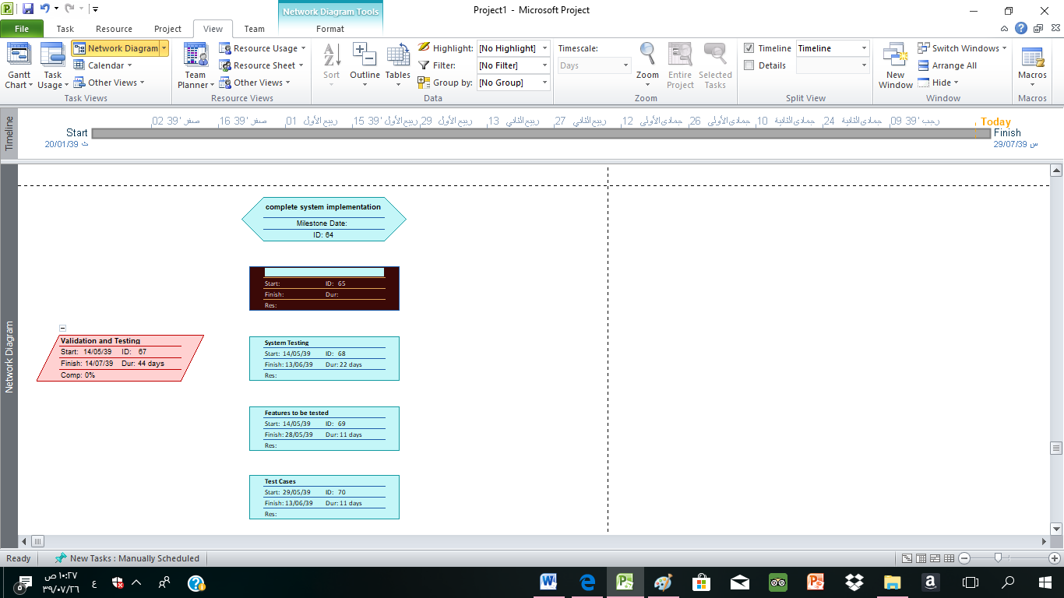

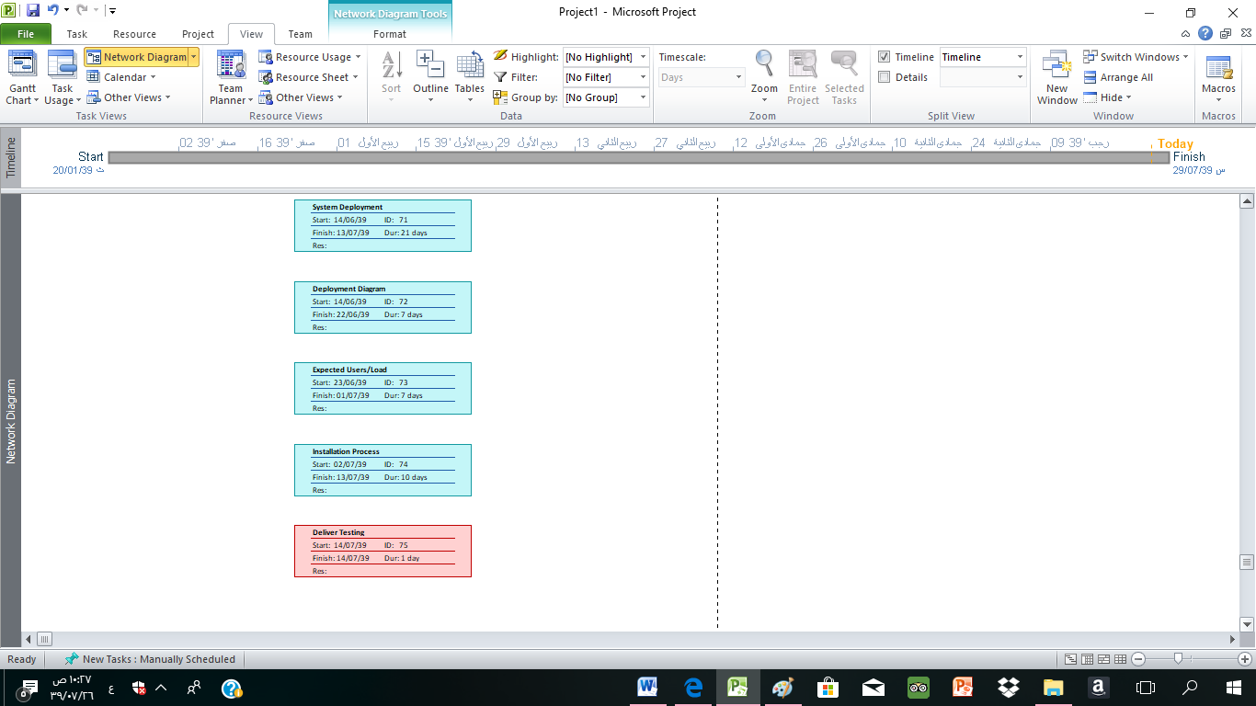

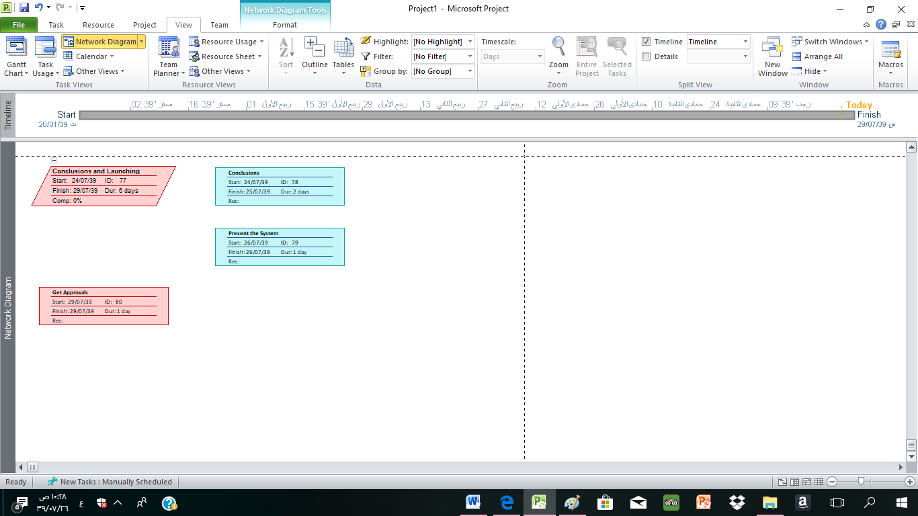

* + Show the **Timeline** view for the **summary tasks**.

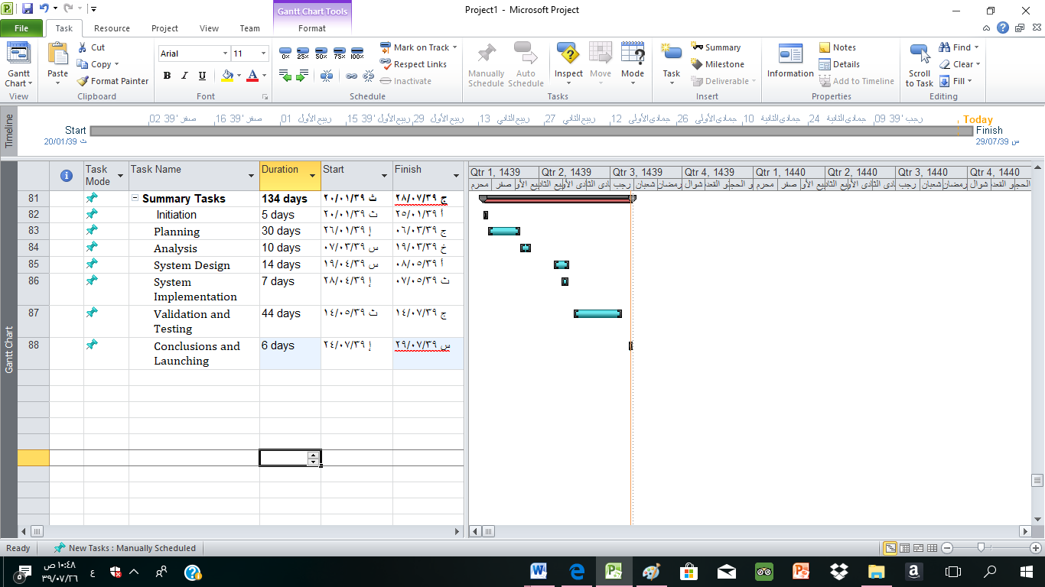

* + Define the needed resources in the resource sheet and make sure that you define the related information (type, cost …etc.). **Show** the resource sheet.

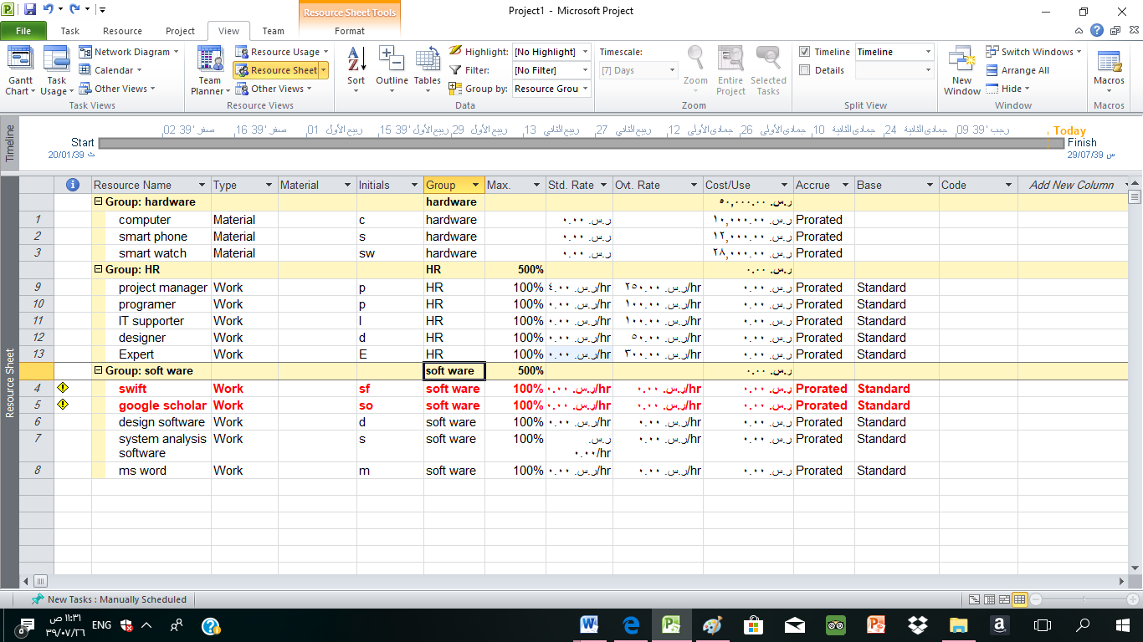

* Assign resources to tasks. **Show** the first assignment. **Show** the over allocation.

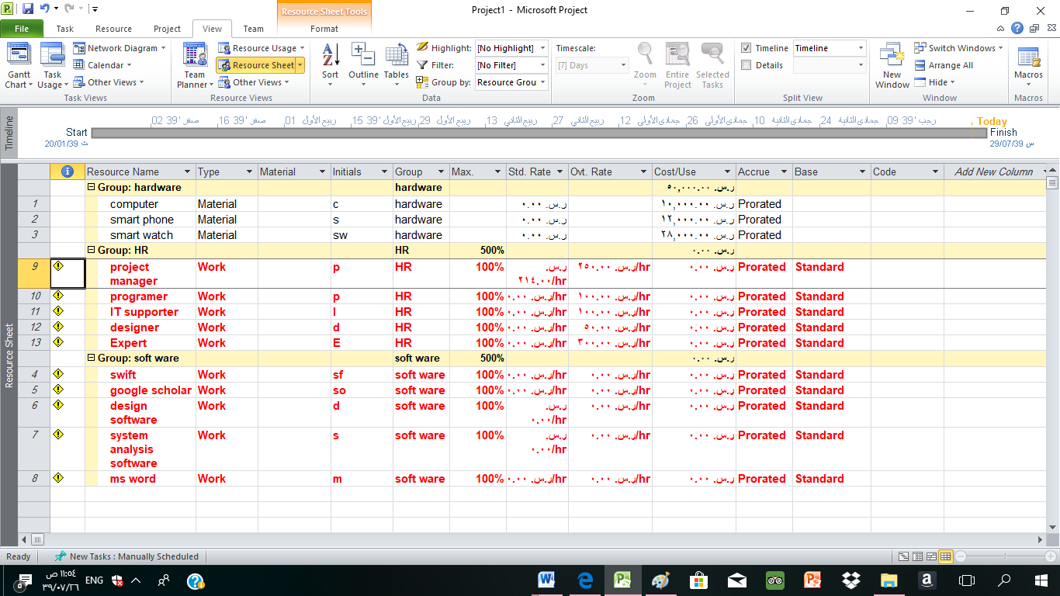

**Assign**

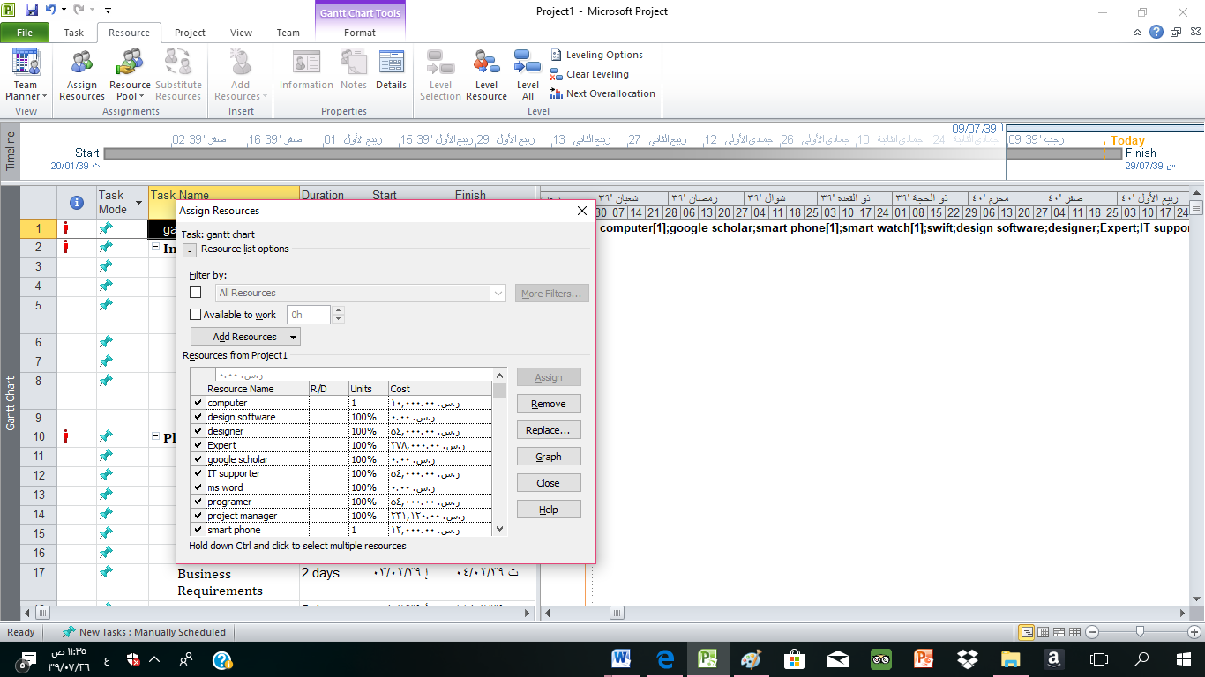

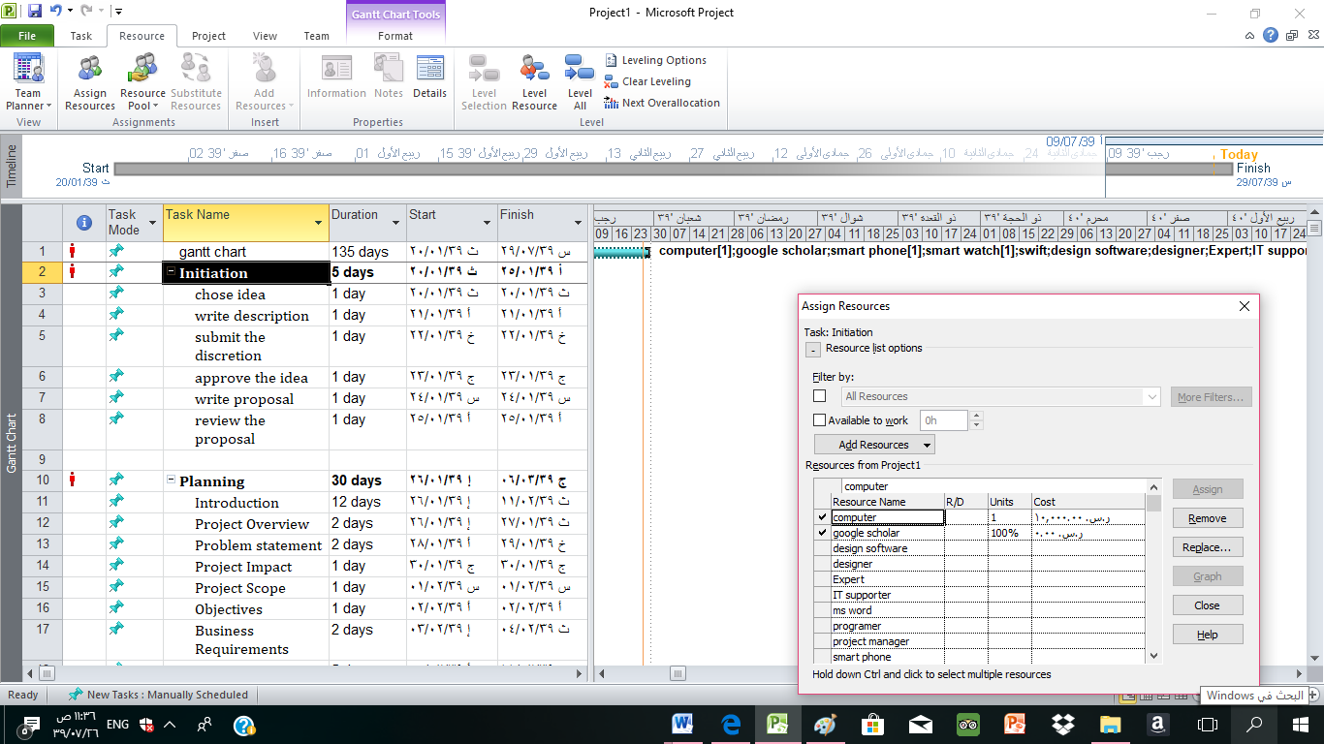

**Part 3: Cost Management**

Ground rules and assumptions:

* Costs will be provided by S.R (Saudi Riyal).
* The employees are working 7 hours a day.
* There is 3 team members.
* There is one project manager.

1. Initiation
   1. chose idea: it will take 1 day so project manager is working for 7 hours and team members also 7 hours and we need to meet an expert to ask him about the idea for half hour only.
   2. write description: it will take 1 day so project manager is working for 7 hours and team members also 7 hours
   3. submit the discretion: it will take 1 day so project manager is working for 7 hours and team members also 7 hours
   4. approve the idea: it will take 1 day so project manager is working for 7 hours and team members also 7 hours
   5. write proposal: it will take 1 day so project manager is working for 7 hours and team members also 7 hours.
   6. review the proposal: it will take 1 day so project manager is working for 7 hours and team members also 7 hours
2. Planning
   1. Introduction
      1. Project Overview: it will take 2 days so project manager is working for 14 hours and team members also 14 hours.
      2. Problem statement: it will take 2 days so project manager is working for 14 hours and team members also 14 hours.
      3. Project Impact: it will take 1 day so project manager is working for 7 hours and team members also 7 hours
      4. Project Scope: it will take 1 day so project manager is working for 7 hours and team members also 7 hours
      5. Objectives: it will take 1 day so project manager is working for 7 hours and team members also 7 hours
      6. Business Requirements: it will take 2 days so project manager is working for 14 hours and team members also 14 hours.
      7. Alternative solution: it will take 5 days so project manager is working for 35 hours and team members also 35 hours.
   2. Background
      1. Overview of existing systems: it will take 5 days so project manager is working for 35 hours and team members also 35 hours.
      2. Existing Business Processes: it will take 2 days so project manager is working for 14 hours and team members also 14 hours.
      3. Method / Approach: it will take 3 days so project manager is working for 21 hours and team members also 21 hours the expert will help in determine which method to use we need only one hour from expert to determine.
      4. Project Planning: it will take 5 days so project manager is working for 35 hours and team members also 35 hours.
   3. Deliver planning: it will take 1 day so project manager is working for 7 hours and team members also 7 hours
3. Analysis
   1. Requirement Gathering Techniques
      1. Do questionnaire: one of the team members will create this questionnaire and she need only one hour to create it.
      2. Do interview: one of the team members will do this interview and she need two hours to do it.
   2. Proposed Business Process: it will take 1 day so project manager is working for 7 hours and team members also 7 hours
   3. Functional Requirements
      1. Use-case diagram: it will take 2 days so project manager is working for 14 hours and team members also 14 hours.
      2. Use-case descriptions: it will take 2 days so project manager is working for 14 hours and team members also 14 hours.
   4. Non-functional Requirements: it will take 1 day so project manager is working for 7 hours and team members also 7 hours.
   5. User Interfaces: it will take 5 days so project manager is working for 35 hours and team members also 35 hours.
   6. Deliver Analysis: it will take 1 day so project manager is working for 7 hours and team members also 7 hours.
4. System Design
   1. System Modelling
      1. Activity diagrams: it will take 6 days so project manager is working for 42 hours and team members also 42 hours.
      2. Class Diagram: it will take 2 days so project manager is working for 14 hours and team members also 14 hours.
      3. Sequence Diagrams: it will take 2 days so project manager is working for 14 hours and team members also 14 hours.
   2. Data Modelling
      1. ER Diagram: it will take 1 day so project manager is working for 7 hours and team members also 7 hours.
      2. Data Dictionary: it will take 1 day so project manager is working for 7 hours and team members also 7 hours.
   3. Detailed Interface Design: it will take 2 days so project manager is working for 14 hours and team members also 14 hours.
   4. Component Diagram: it will take 2 days so project manager is working for 14 hours and team members also 14 hours.
   5. Alternative Designs: it will take 4 days so project manager is working for 28 hours and team members also 28 hours. and we need a designer to help in designing so he will be working for 28 hours.
   6. Deliver Design: it will take 1 day so project manager is working for 7 hours and team members also 7 hours.
5. System Implementation
   1. System Specification
      1. Hardware Specifications: it will take 3 days so project manager is working for 21 hours and team members also 21 hours. and the hardware needed are 5 computers each computer cost 2000 S.R so (5 x 2000 =10000 S.R), 4 smartphones each one cost 3000 S.R so (4 x 3000 =12000 S.R) and 28 smart watches each one cost 1000 S.R so (28 x 1000 =28000 S.R)
      2. Software Specifications: it will take 3 days so project manager will cost (214 x 21 = 4494 S.R) and team members (100 x 21 =2100 S.R).
   2. Deliver Implementation: it will take 1 day so project manager is working for 7 hours and team members also 7 hours.
6. Validation and Testing
   1. System Testing
      1. Features to be tested: it will take 11 days so project manager is working for 77 hours and team members also 77 hours.
      2. Test Cases: it will take 11 days so project manager is working for 77 hours and team members also 77 hours.
   2. System Deployment
      1. Deployment Diagram: it will take 7 days so project manager is working for 49 hours and team members also 49 hours.
      2. Expected Users/Load: it will take 7 days so project manager is working for 49 hours and team members also 49 hours.
      3. Installation Process: it will take 7 days so project manager is working for 49 hours and team members also 49 hours.
   3. Deliver Testing: it will take 1 day so project manager is working for 7 hours and team members also 7 hours.
7. Conclusions and Launching
   1. Conclusion: it will take 2 days so project manager is working for 14 hours and team members also 14 hours.
   2. Present the System: it will take 1 day so project manager is working for 7 hours and team members also 7 hours.
   3. Get Approvals: it will take 1 day so project manager is working for 7 hours and team members also 7 hours.

cost model using the preceding information is shown in Figure 3.1.

|  |  |  |  |  |
| --- | --- | --- | --- | --- |
| WBS item | Units/hrs | Cost | Subtotal | WBS Level 2 total |
| **Initiation** |  |  |  | 21,463 S.R |
| Project manager | 42 | 214 S.R | 8,988 S.R |  |
| Team members | 42 | 300 S.R | 12,300 S.R |  |
| Expert | 0.5 | 350 S.R | 175 S.R |  |
| **Planning** |  |  |  | 108,290 S.R |
| Project manager | 210 | 214 S.R | 44,940 S.R |  |
| Team members | 210 | 300 S.R | 63,000 S.R |  |
| Expert | 1 | 350 S.R | 350 S.R |  |
| **Analysis** |  |  |  | 44,718 S.R |
| Project manager | 87 | 214 S.R | 18,618 S.R |  |
| Team members | 87 | 300 S.R | 26,100 S.R |  |
| **System Design** |  |  |  | 78,358 S.R |
| Project manager | 147 | 214 S.R | 31,458 S.R |  |
| Team members | 147 | 300 S.R | 44,100 S.R |  |
| Designer | 28 | 100 S.R | 2,800 S.R |  |
| **System Implementation** |  |  |  |  |
| Project manager | 49 | 214 S.R | 10,486 S.R | 75,186 S.R |
| Team members | 49 | 300 S.R | 14,700 S.R |  |
| Hardware | - | 50000 S.R | 50000 S.R |  |
| **Validation and Testing** |  |  |  | 158,312 S.R |
| Project manager | 308 | 214 S.R | 65,912 S.R |  |
| Team members | 308 | 300 S.R | 92,400 S.R |  |
| **Conclusions and Launching** |  |  |  | 14,392 S.R |
| Project manager | 28 | 214 S.R | 5,992 S.R |  |
| Team members | 28 | 300 S.R | 8,400 S.R |  |
| Total project estimate |  |  |  | 500,719 S.R |

**Figure 3.1:** Alzheimer watch project cost estimate.

Baseline is shown in Figure 3.2

|  |  |  |  |  |  |  |  |  |  |  |  |  |  |
| --- | --- | --- | --- | --- | --- | --- | --- | --- | --- | --- | --- | --- | --- |
| WBS item | 1 | 2 | 3 | 4 | 5 | 6 | 7 | 8 | 9 | 10 | 11 | 12 | Totals |
| **Initiation** |  |  |  |  |  |  |  |  |  |  |  |  |  |
| Project manager | 8,988 |  |  |  |  |  |  |  |  |  |  |  | 8,988 |
| Team members | 12,300 |  |  |  |  |  |  |  |  |  |  |  | 12,300 |
| Expert | 175 |  |  |  |  |  |  |  |  |  |  |  | 175 |
| **Planning** |  |  |  |  |  |  |  |  |  |  |  |  |  |
| Project manager | 11,235 | 33,705 |  |  |  |  |  |  |  |  |  |  | 44,940 |
| Team members | 15,750 | 47,250 |  |  |  |  |  |  |  |  |  |  | 63,000 |
| Expert | 350 |  |  |  |  |  |  |  |  |  |  |  | 350 |
| **Analysis** |  |  |  |  |  |  |  |  |  |  |  |  |  |
| Project manager |  |  | 18,618 |  |  |  |  |  |  |  |  |  | 18,618 |
| Team members |  |  | 26,100 |  |  |  |  |  |  |  |  |  | 26,100 |
| **System Design** |  |  |  |  |  |  |  |  |  |  |  |  |  |
| Project manager |  |  |  | 26,964 | 4,494 |  |  |  |  |  |  |  | 31,458 |
| Team members |  |  |  | 37,800 | 6,300 |  |  |  |  |  |  |  | 44,100 |
| Designer |  |  |  |  | 2,800 |  |  |  |  |  |  |  | 2,800 |
| **System Implementation** |  |  |  |  |  |  |  |  |  |  |  |  |  |
| Project manager |  |  | 2,621.5 | 7,864.5 |  |  |  |  |  |  |  |  | 10,486 |
| Team members |  |  | 3,675 | 11,025 |  |  |  |  |  |  |  |  | 14,700 |
| Hardware |  |  | 50000 |  |  |  |  |  |  |  |  |  | 50000 |
| **Validation and Testing** |  |  |  |  |  |  |  |  |  |  |  |  |  |
| Project manager |  |  |  | 5,992 | 5,992 | 53,928 |  |  |  |  |  |  | 65,912 |
| Team members |  |  |  | 8,400 | 8,400 | 75,600 |  |  |  |  |  |  | 92,400 |
| **Conclusions and Launching** |  |  |  | 14,392 |  |  |  |  |  |  |  |  |  |
| Project manager |  |  |  |  |  | 5,992 |  |  |  |  |  |  | 5,992 |
| Team members |  |  |  |  |  | 8,400 |  |  |  |  |  |  | 8,400 |
| Totals | 39,810 | 80,955 | 101,014.5 | 112,437.5 | 27,986 | 143,920 |  |  |  |  |  |  | 500,719 |

**Figure 3.2:** Alzheimer watch project cost baseline

**Part 4: Tracking project flow for the proposed project**

* + - * Show the status of each task (on schedule, ahead schedule, or behind schedule).

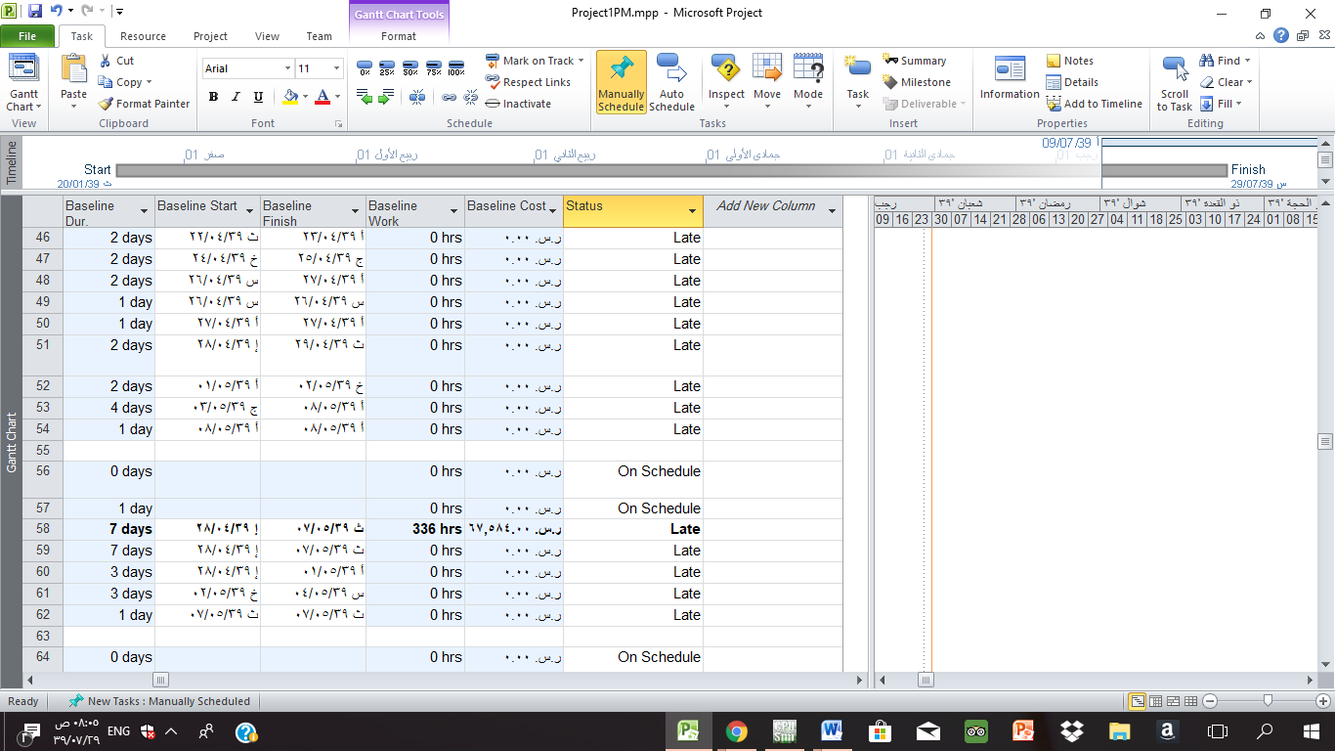

* + - * Show Track Gantt chart.

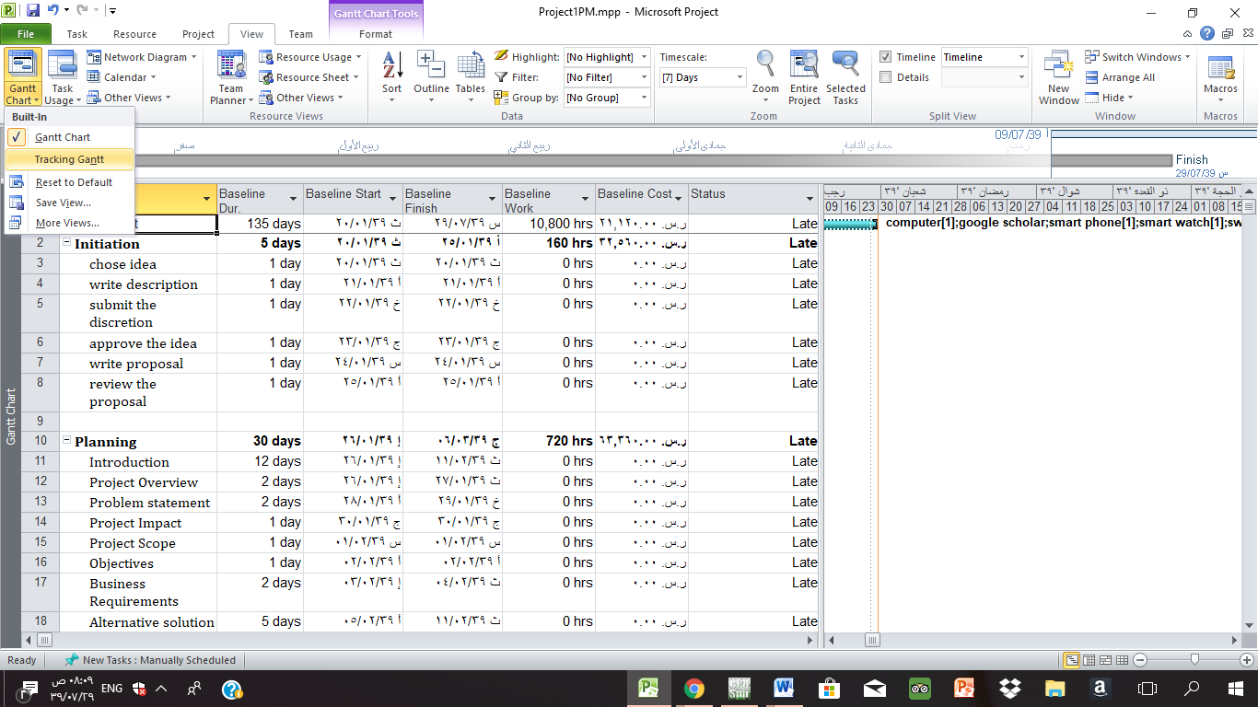

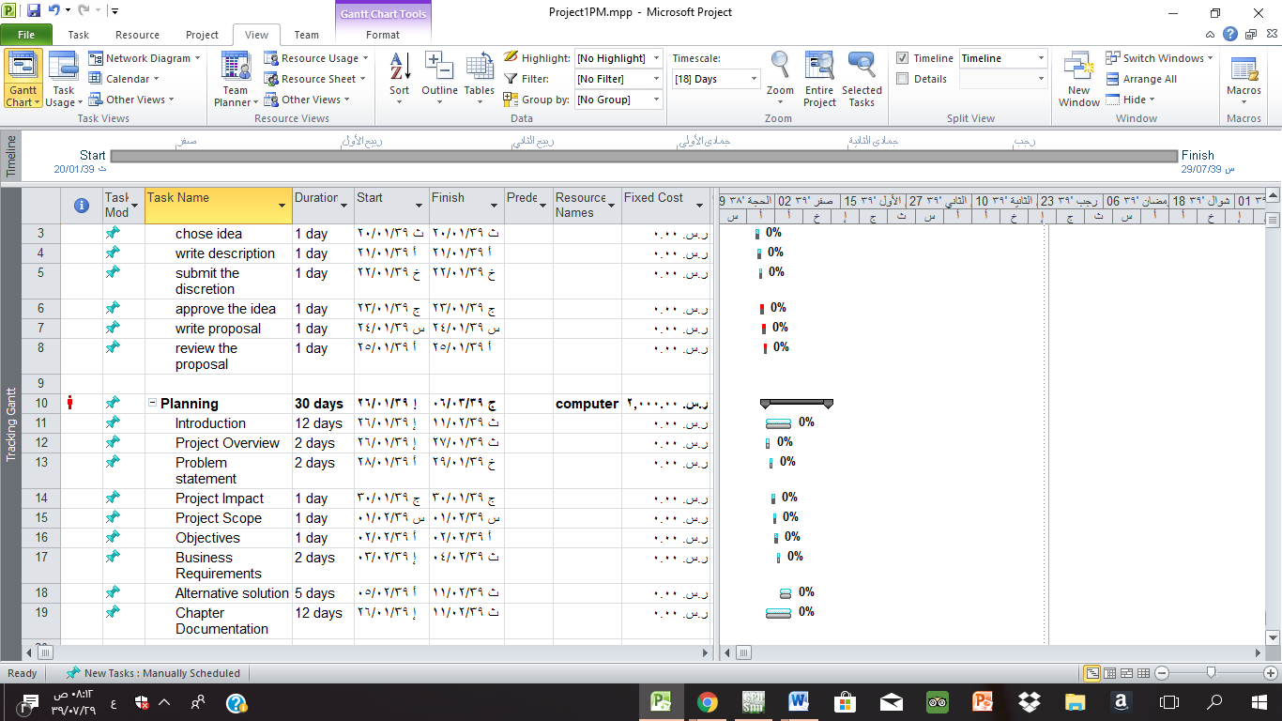

* + - * Show variance table.

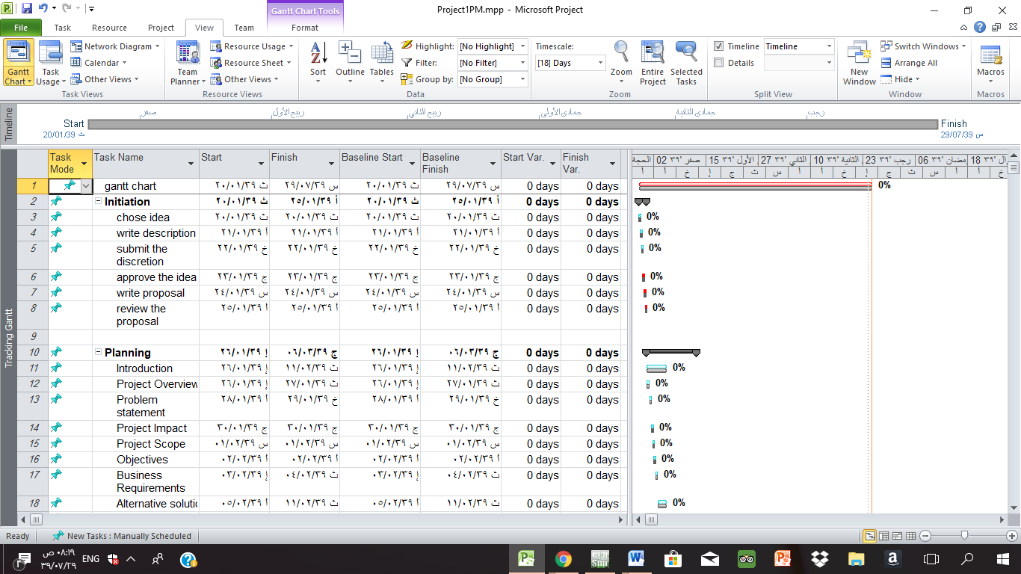

* + - * Show the EVM table.

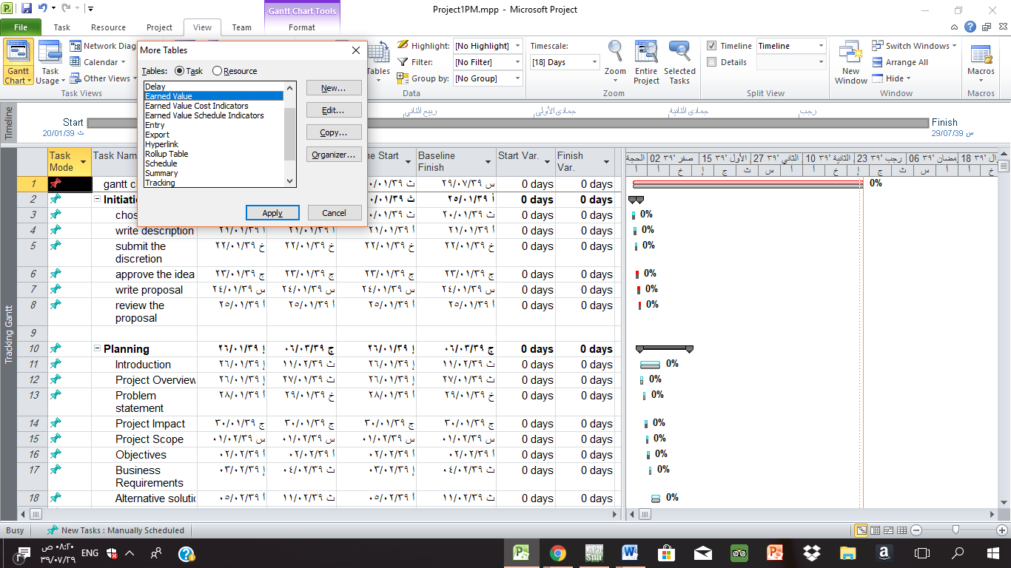

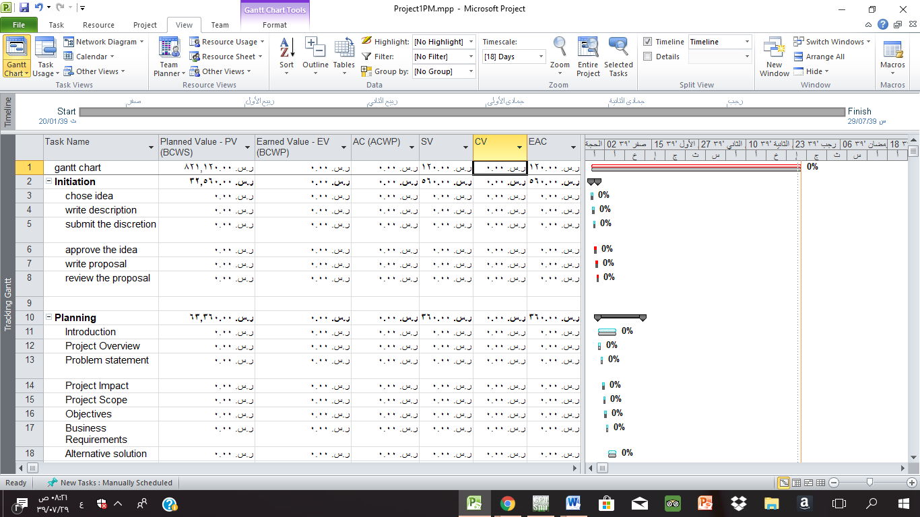

* + - * Reschedule show steps and final result.

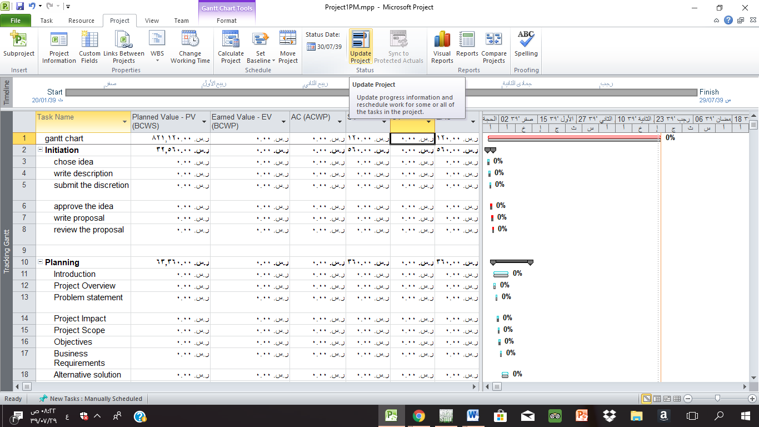

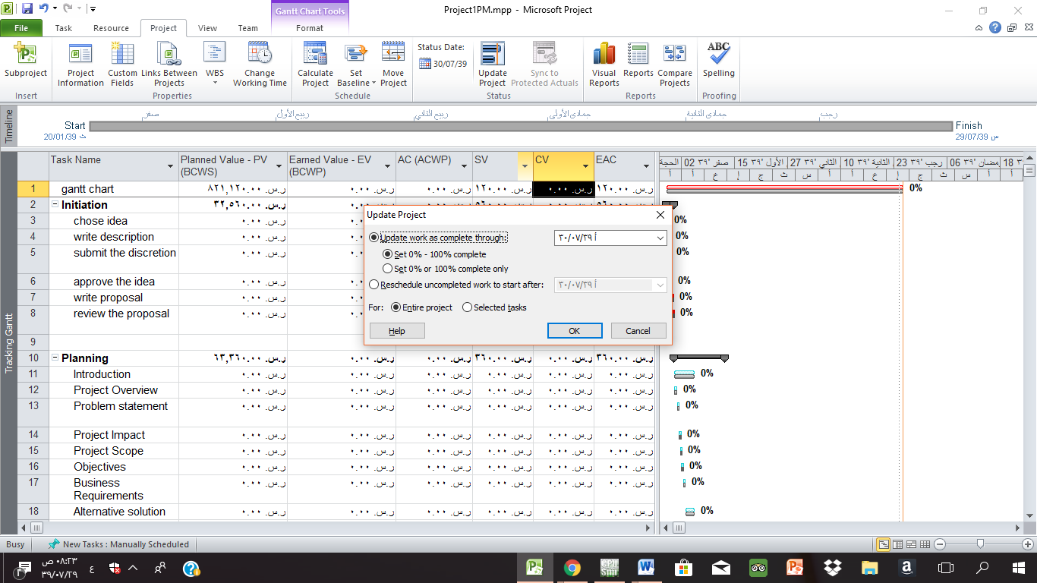

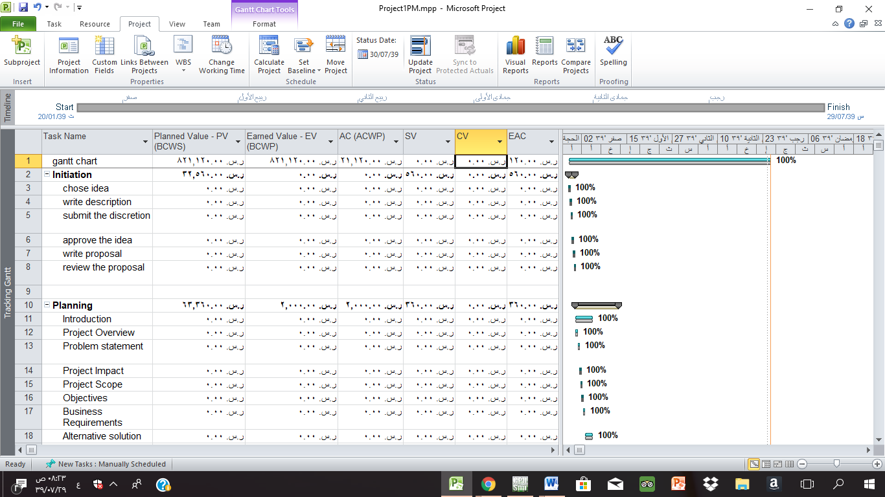

1. Create **custom view** with name (IS441) that is copy of Gantt chart that shows a custom table with the following data (Actual Start Date, Actual Finish date, Start Date, Finish Date, Duration, SV, Completion %, CV).

